ADDO WISDOM (INDEX NUMBER:4154215)

INDUSTRIAL ENGINEERING AND ERGONOMICS (ME 392)

ASSIGNMENT 2 (12TH APRIL,2018)

MATERIAL HANDLING SYSTEM

Materials handling involves use of diverse range of tools, vehicles, storage units, appliances and accessories involved in transporting, storing, controlling, enumerating and protecting products at any stage of manufacturing, distribution consumption or disposal. It is divided into four (4) categories. These are:

1. Storage and Handling System(Equipment)
2. Engineered System(Equipment)
3. Industrial trucks
4. Bulk Material Handling System(Equipment)

1. STORAGE AND HANDLING SYSTEM

Storage and Handling System is usually limited to non-automated examples, which are grouped in with engineered systems. Storage equipment is used to hold or buffer materials during times when they are not being transported. These periods could refer to temporary pauses during long-term transportation or long-term storage designed to allow the buildup of stock. The majority of storage equipment refers to pallets, shelves or racks onto which materials may be stacked in an orderly manner to await transportation or consumption. Examples of Storage and Handling system are:

* Racks, such as pallet racks, drive-through or drive-in racks, push-back racks, and sliding racks
* Stacking frames
* Shelves, bins and drawers
* 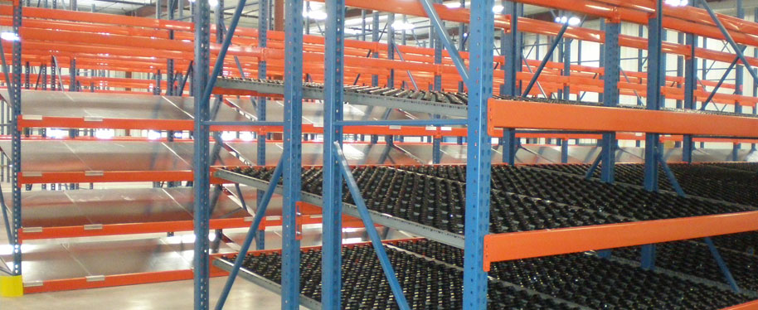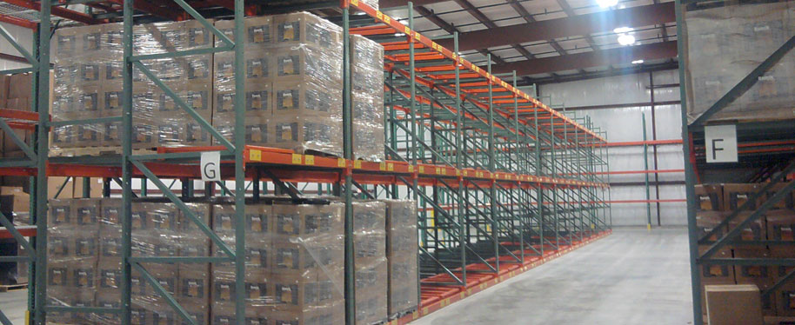Mezzanines

Shelves

Stacking frames

2. ENGINEERED SYSTEM

Engineered systems cover a variety of units that work cohesively to enable storage and transportation. They are often automated. A good example of an engineered system is an Automated Storage and Retrieval System, often abbreviated AS/RS, which is a large automated organizational structure involving racks, aisles and shelves accessible by a “shuttle” system of retrieval. The shuttle system is a mechanized cherry picker that can be used by a worker or can perform fully automated functions to quickly locate a storage item’s location and quickly retrieve it for other uses. The conveyor is made of metal strips constructed together to form a platform which moves materials from one station to the other. The engineered systems are:

* Conveyor systems
* Robotic delivery systems
* 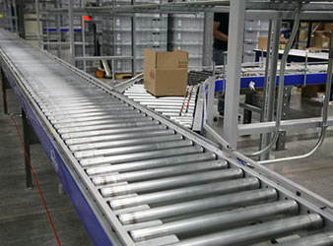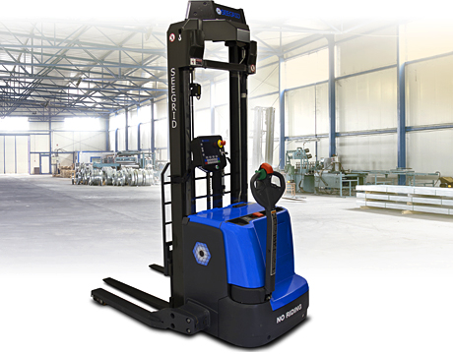Automatic guided vehicles (AGV)

Conveyor

AGV

3. INDUSTRIAL TRUCKS

Industrial trucks refer to the different kinds of transportation items and vehicles used to move materials and products in materials handling. These transportation devices can include small hand-operated trucks, pallet-jacks, and various kinds of forklifts. These trucks have a variety of characteristics to make them suitable for different operations. Some trucks have forks, as in a forklift, or a flat surface with which to lift items, while some trucks require a separate piece of equipment for loading. Trucks can also be manual or powered lift and operation can be walk or ride, requiring a user to manually push them or to ride along on the truck. Some examples are:

* Hand trucks
* Pallet jacks
* Walkie stackers
* Platform trucks
* Order picker
* Sideloader

4. BULK MATERIAL HANDLING SYSTEM

Bulk material handling refers to the storing, transportation and control of materials in loose bulk form. These materials can include food, liquid, or minerals, among others. Generally, these pieces of equipment deal with the items in loose form, such as conveyor belts or elevators designed to move large quantities of material, or in packaged form, through the use of drums and hoppers.

* Conveyor belts
* Stackers
* Reclaimers
* Bucket elevators
* Grain elevators
* Hoppers
* Silos